**Lab 8 – SSL/TLS**

**IT 520-A – Enterprise Infrastructure & Networks**

**Due Date: April 17th, 2018**

**Michael Weiler**

Instructions:

Capture your packets in an SSL session. To do this, you should go to your favorite e-commerce site and begin the process of purchasing an item (but terminating before making the actual purpose!). After capturing the packets with Wireshark, you should set the filter so that it displays only the Ethernet frames that contain SSL records sent from and received by your host. (An SSL record is the same thing as an SSL message.)

Your Wireshark GUI should be displaying only the Ethernet frames that have SSL records. It is important to keep in mind that an Ethernet frame may contain one or more SSL records. (This is very different from HTTP, for which each frame contains either one complete HTTP message or a portion of a HTTP message.) Also, an SSL record may not completely fit into an Ethernet frame, in which case multiple frames will be needed to carry the record. Locate the “Client Hello” and “Server Hello” frame and use the frames to answer the questions.

• For each question, take a screenshot of your response. I’ll not grade any question answered without a screenshot.

• Take a screenshot of your computer’s IP address. 192.168.43.190

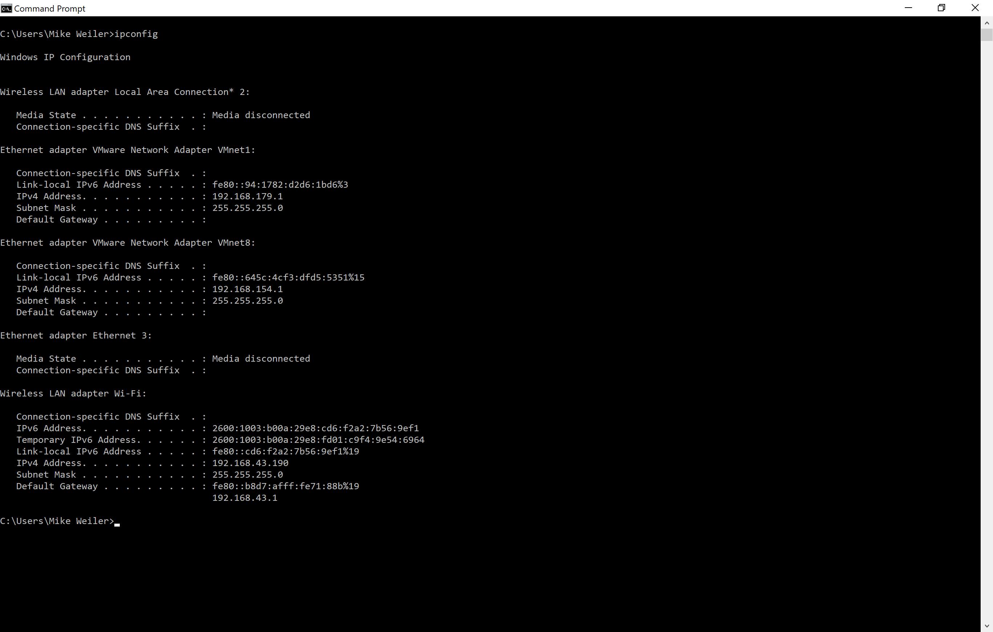

Questions:

Client Hello Record:

1. What is the SSL/TLS version of the of the Client Hello frame? TLS1.2

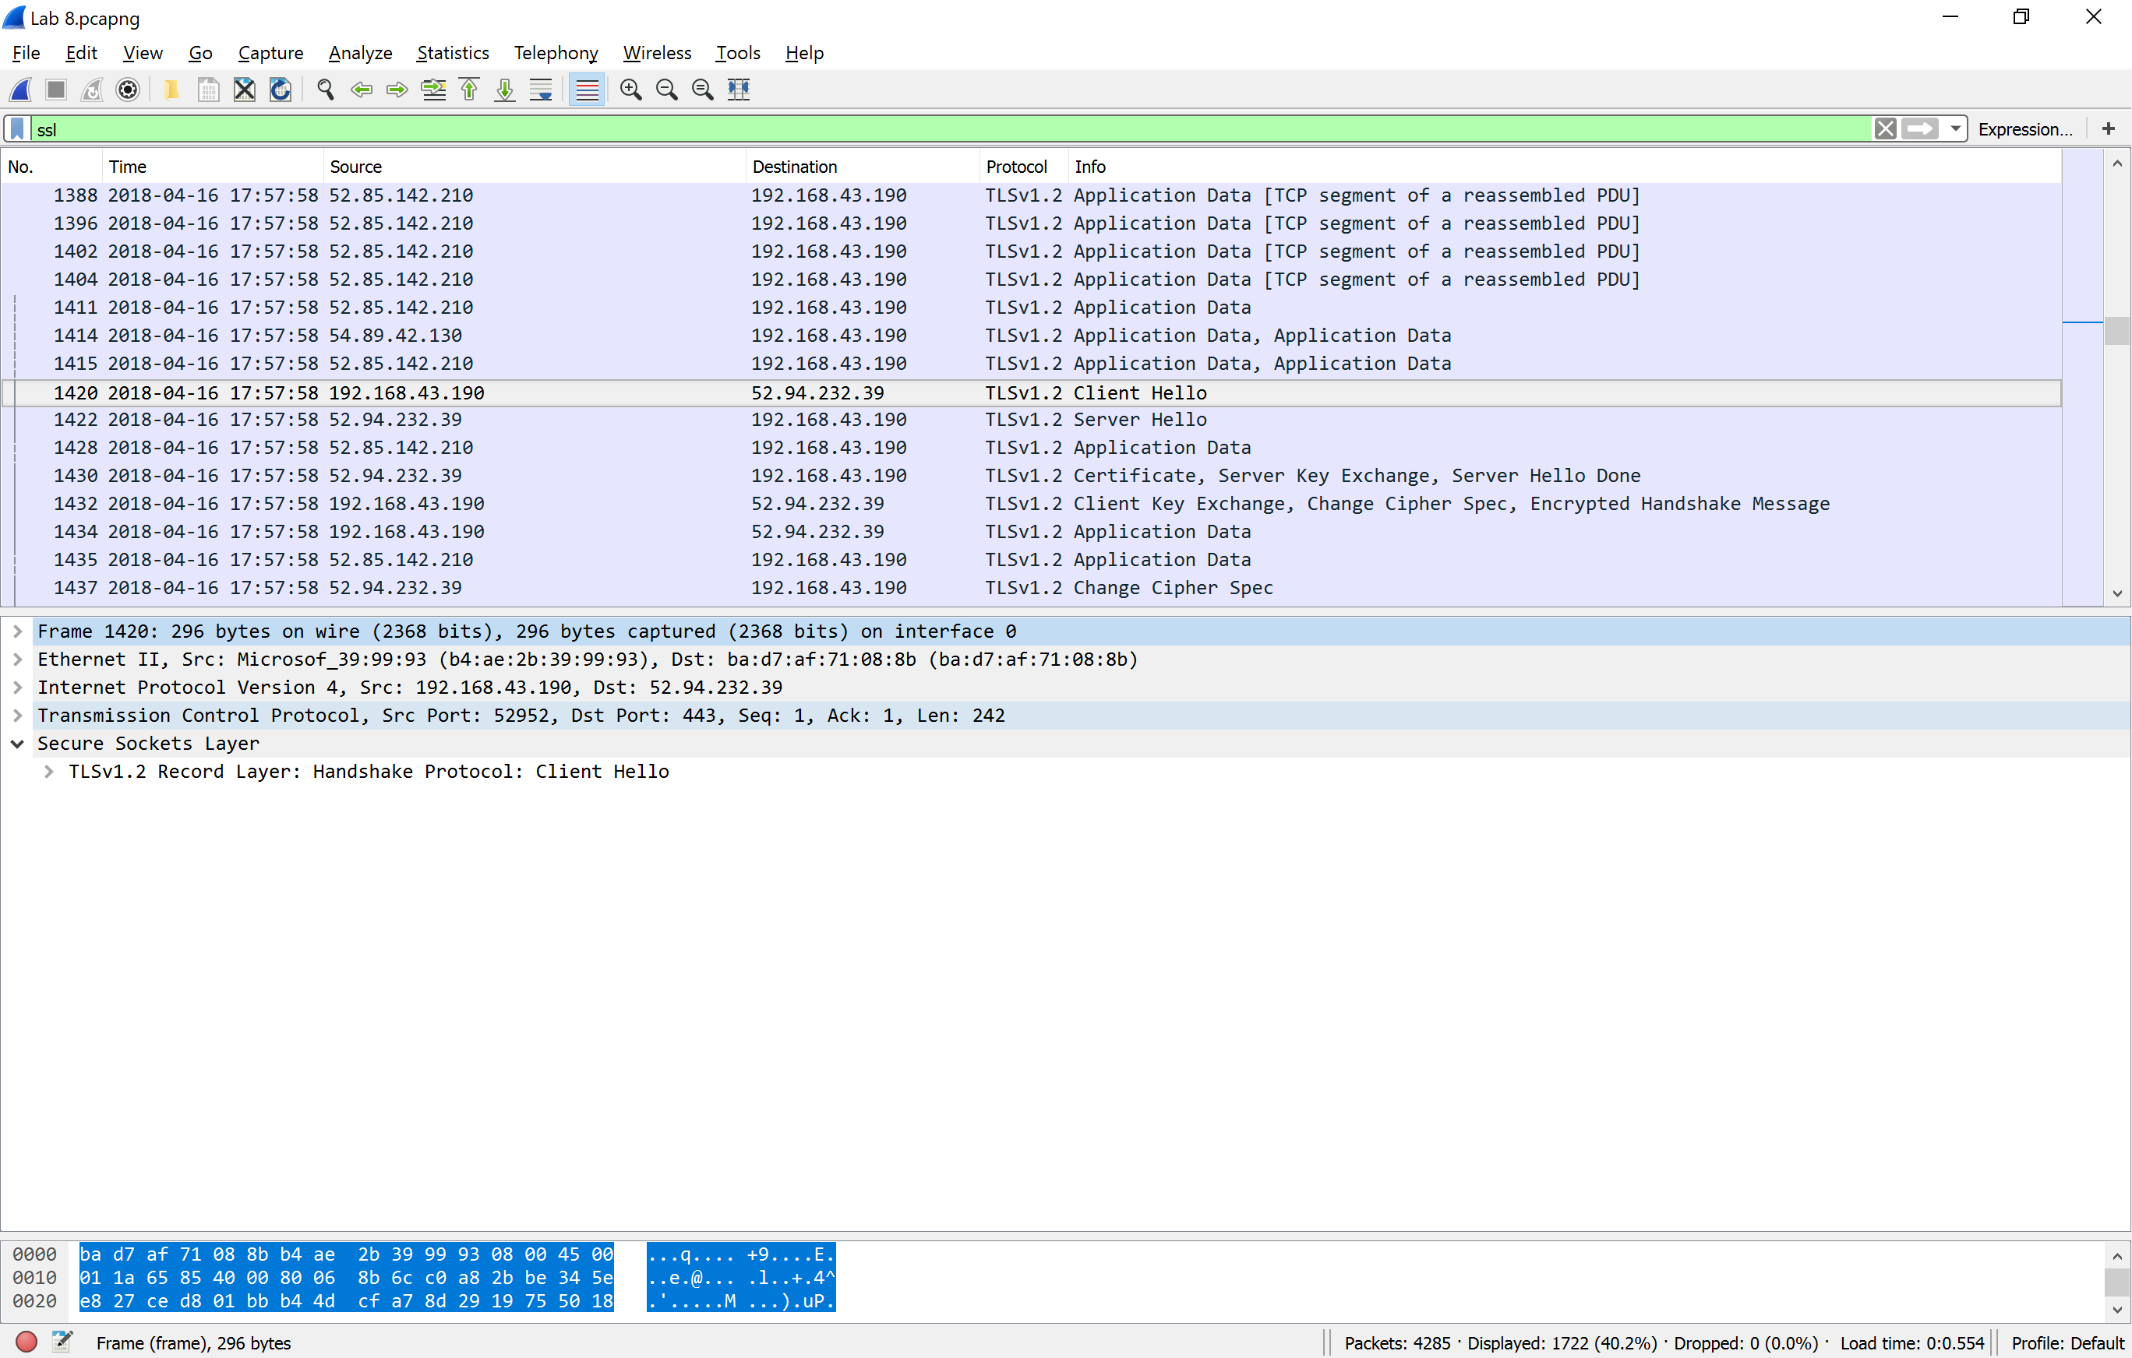

1. Expand the ClientHello record. (If your trace contains multiple ClientHello records, expand the frame that contains the first one.) What is the value of the content type? 22

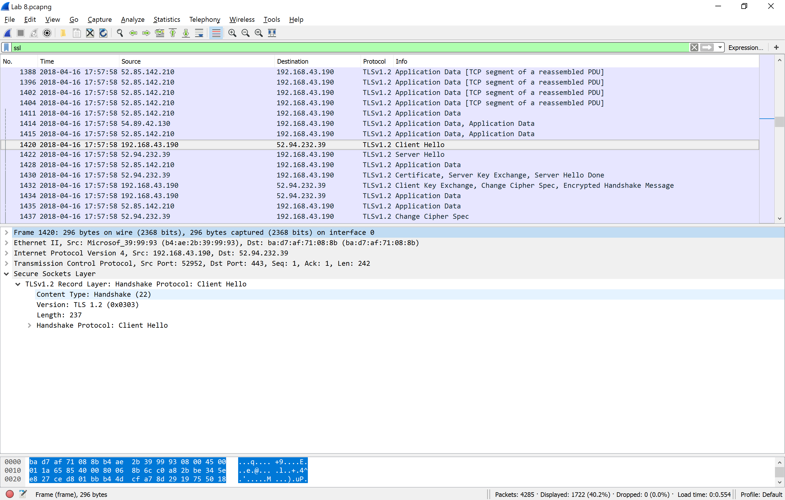

1. Does the ClientHello record contain a nonce (also known as a “challenge”)? If so, what is the value of the challenge in hexadecimal notation? NONE

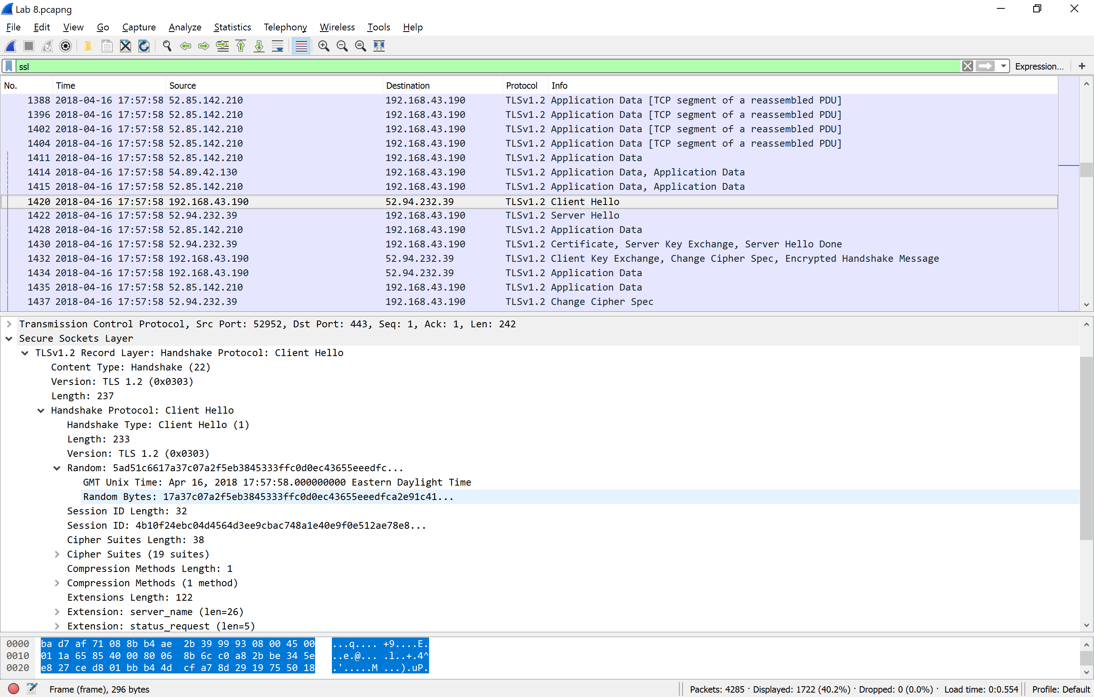

1. Does the ClientHello record advertise the cyber suites it supports? If so, in the first listed suite, what are the public-key algorithm, the symmetric-key algorithm, and the hash algorithm?

Cipher Suites Length: 38

Cipher Suites (19 suites)

Cipher Suite: TLS_ECDHE_ECDSA_WITH_AES_256_GCM_SHA384 (0xc02c)

Cipher Suite: TLS_ECDHE_ECDSA_WITH_AES_128_GCM_SHA256 (0xc02b)

Cipher Suite: TLS_ECDHE_RSA_WITH_AES_256_GCM_SHA384 (0xc030)

Cipher Suite: TLS_ECDHE_RSA_WITH_AES_128_GCM_SHA256 (0xc02f)

Cipher Suite: TLS_ECDHE_ECDSA_WITH_AES_256_CBC_SHA384 (0xc024)

Cipher Suite: TLS_ECDHE_ECDSA_WITH_AES_128_CBC_SHA256 (0xc023)

Cipher Suite: TLS_ECDHE_RSA_WITH_AES_256_CBC_SHA384 (0xc028)

Cipher Suite: TLS_ECDHE_RSA_WITH_AES_128_CBC_SHA256 (0xc027)

Cipher Suite: TLS_ECDHE_ECDSA_WITH_AES_256_CBC_SHA (0xc00a)

Cipher Suite: TLS_ECDHE_ECDSA_WITH_AES_128_CBC_SHA (0xc009)

Cipher Suite: TLS_ECDHE_RSA_WITH_AES_256_CBC_SHA (0xc014)

Cipher Suite: TLS_ECDHE_RSA_WITH_AES_128_CBC_SHA (0xc013)

Cipher Suite: TLS_RSA_WITH_AES_256_GCM_SHA384 (0x009d)

Cipher Suite: TLS_RSA_WITH_AES_128_GCM_SHA256 (0x009c)

Cipher Suite: TLS_RSA_WITH_AES_256_CBC_SHA256 (0x003d)

Cipher Suite: TLS_RSA_WITH_AES_128_CBC_SHA256 (0x003c)

Cipher Suite: TLS_RSA_WITH_AES_256_CBC_SHA (0x0035)

Cipher Suite: TLS_RSA_WITH_AES_128_CBC_SHA (0x002f)

Cipher Suite: TLS_RSA_WITH_3DES_EDE_CBC_SHA (0x000a)

Compression Methods Length: 1

Compression Methods (1 method)

Extensions Length: 122

Extension: server_name (len=26)

Extension: status_request (len=5)

Extension: supported_groups (len=8)

Extension: ec_point_formats (len=2)

Extension: signature_algorithms (len=20)

Extension: SessionTicket TLS (len=0)

Extension: application_layer_protocol_negotiation (len=14)

Extension: extended_master_secret (len=0)

Extension: token_binding (len=6)

Extension: renegotiation_info (len=1)

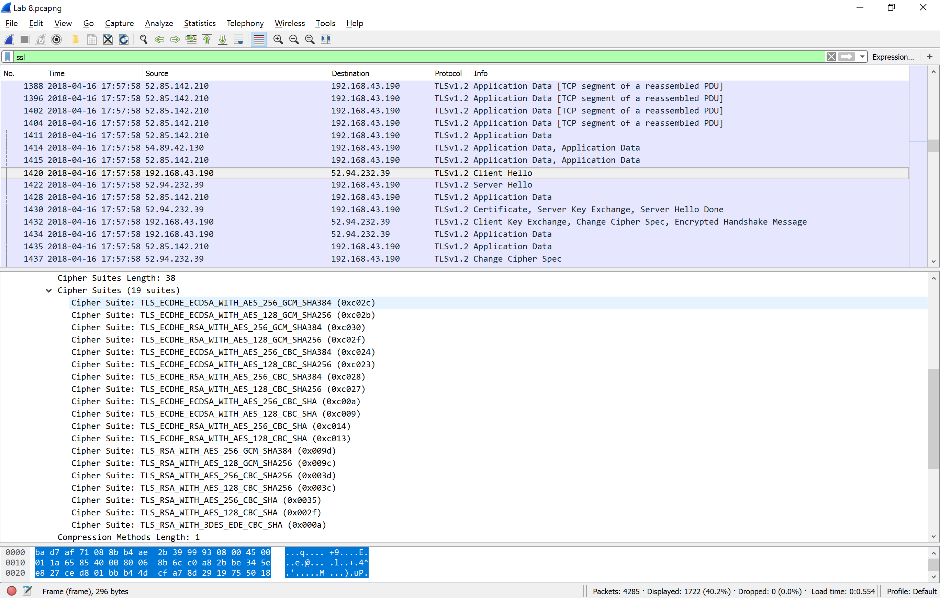

Server Hello Record:

1. Locate the ServerHello SSL record. Does this record specify a chosen cipher suite? What are the algorithms in the chosen cipher suite?

Cipher Suite: TLS_ECDHE_ECDSA_WITH_AES_256_GCM_SHA384 (0xc02c)

19 total

Cipher Suites Length: 38

Cipher Suites (19 suites)

Cipher Suite: TLS_ECDHE_ECDSA_WITH_AES_256_GCM_SHA384 (0xc02c)

Cipher Suite: TLS_ECDHE_ECDSA_WITH_AES_128_GCM_SHA256 (0xc02b)

Cipher Suite: TLS_ECDHE_RSA_WITH_AES_256_GCM_SHA384 (0xc030)

Cipher Suite: TLS_ECDHE_RSA_WITH_AES_128_GCM_SHA256 (0xc02f)

Cipher Suite: TLS_ECDHE_ECDSA_WITH_AES_256_CBC_SHA384 (0xc024)

Cipher Suite: TLS_ECDHE_ECDSA_WITH_AES_128_CBC_SHA256 (0xc023)

Cipher Suite: TLS_ECDHE_RSA_WITH_AES_256_CBC_SHA384 (0xc028)

Cipher Suite: TLS_ECDHE_RSA_WITH_AES_128_CBC_SHA256 (0xc027)

Cipher Suite: TLS_ECDHE_ECDSA_WITH_AES_256_CBC_SHA (0xc00a)

Cipher Suite: TLS_ECDHE_ECDSA_WITH_AES_128_CBC_SHA (0xc009)

Cipher Suite: TLS_ECDHE_RSA_WITH_AES_256_CBC_SHA (0xc014)

Cipher Suite: TLS_ECDHE_RSA_WITH_AES_128_CBC_SHA (0xc013)

Cipher Suite: TLS_RSA_WITH_AES_256_GCM_SHA384 (0x009d)

Cipher Suite: TLS_RSA_WITH_AES_128_GCM_SHA256 (0x009c)

Cipher Suite: TLS_RSA_WITH_AES_256_CBC_SHA256 (0x003d)

Cipher Suite: TLS_RSA_WITH_AES_128_CBC_SHA256 (0x003c)

Cipher Suite: TLS_RSA_WITH_AES_256_CBC_SHA (0x0035)

Cipher Suite: TLS_RSA_WITH_AES_128_CBC_SHA (0x002f)

Cipher Suite: TLS_RSA_WITH_3DES_EDE_CBC_SHA (0x000a)

1. 